**“Short-Term WTI Price Forecasting”**

Research funded by the Institute for Advanced Teaching and Learning at the University of Warwick

Student researcher: Bogdan-Remus Pintilie

Supervisor: Dr. Zeynep Ozde Kurter, Dr. Michael Mortenson

Repository: https://github.com/BogdanRemusPintilie/Short-Term-WTI-Price-Forecasting

October 2024

© Bogdan-Remus Pintilie, 2024

**Abstract**

WTI (West Texas Intermediate) is a grade of crude oil produced in the United States, specifically in Texas, and is one of the most important benchmarks for oil prices globally. The project aims to predict the evolution of WTI’s price and standard deviation using time series models. Texas’ temperature is also forecasted and used as an exogenous variable in forecasting WTI’s price. The data frame used contains daily data (WTI’s price, Texas’ temperature, etc.) from 07/July/2020 to 03/September/2024. I converted it into weekly observations because working with daily data made it computationally difficult to fit the model and predict values (Figure 1).

Figure 1. Error encountered

Furthermore, the project provides a fundamentals-based explanation of the spread between two different grades of crude oil (i.e., WTI and Dubai) and a modality to trade it. The project resulted in modelling Texas’ temperature using a SARIMA (0,0,0)(1,1,1,52) model (4.948 °C root mean squared error, RMSE, and a 0.184 mean absolute percent error, MAPE), modelling WTI’s price using an ARIMAX (2,1,2) model ($3.220 RMSE and 0.034 MAPE), modelling WTI’s standard deviation using a GARCH (1,1) model ($0.00536 RMSE and 0.126 MAPE). The hyperparameter optimisation of the models aimed at analysing short lags, from 1 to 4. A wider range of lags could result in a more optimal combination of arguments to use, but it is time-consuming and computationally intensive.

**Data Collection**

There were two ways in which the data was collected. First, I requested data from the National Oceanic and Atmospheric Administration (NOAA) and received data on the temperature recorded at a station in Dallas, Texas, one in Dubai, UAE, and another in the UK. Second, I collected data on WTI’s price from the Federal Reserve Bank of St. Louis, data on Dubai’s crude oil price from Investing.com, and data on Brent from the U.S. Energy Information Administration. I merged the financial and weather data into one Excel file (Data -> Data.csv), which I used throughout the forecasting stages. Thirdly, I wanted to automate data collection, so I used Task Scheduler to run a Python script every hour to retrieve temperature data using OpenWeather’s API. I didn’t end up using the data from the API, but if I were to make trading decisions daily, I would have used it to avoid repetitive data collection. The code can be found in the Data -> API call folder.

**WTI&Dubai spread analysis and trading**

WTI and Dubai have differing prices, and both are for their respective near-month future. Near-month stands for the futures contract with the nearest expiration date. The difference between the prices is called the spread. In this project, the spread will stand for subtracting WTI’s price from Dubai’s price. Here are some fundamental reasons why WTI and Dubai do not have the same price:

**1.** WTI is a light, sweet crude oil with a high API gravity and low sulfur content. This makes it easier and cheaper to refine into higher-value products like gasoline and diesel. Dubai crude is a medium, sour crude oil with a lower API gravity and higher sulfur content. Sour crude is more challenging and costly to refine because it requires more processing to remove sulfur and other impurities.

**2a (Demand).** WTI reflects oil demand and supply in North America. WTI may be cheaper for the U.S. domestic market due to lower transport costs. Dubai crude reflects demand in Asia, particularly from major importers like China, Japan, South Korea, and India. Since Asia is a net importer of crude oil, demand from these countries, including higher transport costs, can support higher prices for Dubai crude.

**2b (Supply).** Dubai crude pricing is directly affected by OPEC production quotas and policies, as the Middle Eastern oil producers are key OPEC members. When OPEC cuts production, the supply of Dubai-related crude grades can tighten, raising prices. The US oil industry is largely independent, and WTI is impacted by U.S. energy policy and regulations.

**3.** Dubai crude is sourced from the Middle East, a region prone to geopolitical tensions and conflicts, which can result in supply disruptions or risks to shipping through key chokepoints like the Strait of Hormuz. These risks can lead to a risk premium on Dubai crude prices. WTI, being produced in a more politically stable environment (the U.S.), is less subject to these types of risks.

**4.** Refiners in different regions may have seasonal preferences for different types of crude. For example, refineries in Asia may favour sour crude (like Dubai) during certain times of the year due to refining configurations or shifts in product demand. U.S. refineries may prefer lighter crudes (like WTI) that are easier to process into gasoline, especially in the lead-up to the summer driving season.

As for trading the spread, I wanted to observe if it displays mean-reverting behaviour over time. Figure 2 shows the spread time series, the dynamic mean and the two thresholds I created to indicate trading entries and exits:

Figure 2. Spread (Dubai - WTI) time series

The average spread value over the project’s data horizon is $2.22. However, I used a dynamic mean updated with every new observation. The spread’s standard deviation over the project’s horizon is $2.833. The two thresholds are each one standard deviation away from the mean.

For the strategy, I wanted to long the spread every time it went below the lower threshold and short the spread every time it went above the upper threshold, expecting mean reversion. The trade size was always one synthetic spread contract (i.e., +/-1 Dubai contract & -/+ 1 WTI contract). All positions held are cleared every time the spread reaches the dynamic mean. These trading rules have resulted in the following P&L evolution (Figure 3):

Figure 3. The strategy’s P&L evolution

Overall, the P&L proves that the spread displays mean-reverting behaviour. If the spread goes beyond any threshold and the algorithm executes an order at the threshold, one would lose money if deciding to clear the position. This explains the dips in the P&L evolution.

**Forecasting WTI’s price and standard deviation**

To forecast WTI’s price, I first needed to obtain forecasted values for Texas’s temperature (i.e., the exogenous variable). The relationship between temperature and oil prices is indirect but significant. For example, higher temperatures increase electricity demand for cooling, boosting crude oil consumption for power generation. Extreme heat can disrupt oil field operations, reducing supply and driving prices up. Besides, it strains pipelines and transport infrastructure, raising logistical costs and influencing prices.

Given the collected temperature data (turned into weekly data), the time series displays a seasonal pattern, which makes it not stationary. SARIMA is recommended because it deals with the seasonality aspect of the data. Through SARIMA, I am taking the first difference between observations that are one year apart from each other, which makes this new time series stationary. Here is what the temperature (Figure 4) and seasonal first difference (Figure 5) look like:

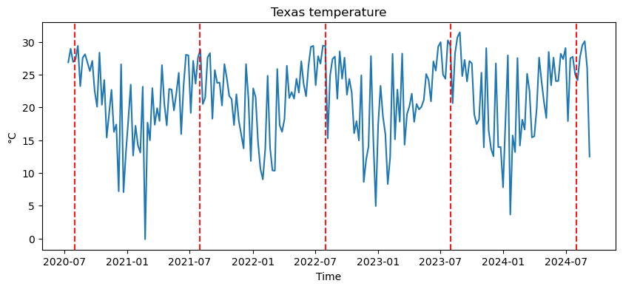

Figure 4. Texas temperature

Figure 5. Seasonal first difference

I used all observations apart from the last four months to train the model and ran some loops to identify the optimal hyperparameters that would result in the lowest Bayesian Information Criterion (BIC). The result was a SARIMA (0,0,0)(1,1,1,52). I then wanted to predict values on a rolling basis, meaning I wanted to predict the test data observations one by one so that at the time of prediction, the model would be updated with the latest data (i.e., previous predictions made). Here is an image of the predictions (Figure 6):

Figure 6. Model validation

Once this was completed, I calculated the rolling residual (difference between the predictions and the test data observations) and some metrics used to evaluate the accuracy of my predictions. The RMSE was 4.974 degrees (i.e., on average, the predicted values deviate from the actual values by 4.974), and the MAPE was 0.183 (i.e., on average, the predictions deviate from the actual values by 18.3%). Here is the rolling residual (Figure 7):

Figure 7. Rolling residual of temperature predictions

This concludes the modelling stage. Moving to the forecasting stage, I used all the data for training and forecasted the next six observations in the same rolling fashion as before. Here are the numbers:

Date Temp (°C)

2024-09-15 24.173870

2024-09-22 26.804093

2024-09-29 24.774267

2024-10-06 20.812450

2024-10-13 20.181995

2024-10-20 18.447748

Here is how the predictions look (Figure 8):

Figure 8. Temperature predictions

Now that I have the temperature forecast, I have moved on to WTI’s price forecasting. I worked with weekly values again but needed to reach stationarity because WTI’s price time series is not stationary. Here is WTI’s price over the project's horizon (Figure 9):

Figure 9. WTI’s price

Here is the WTI’s price first difference (Figure 10), which is stationary:

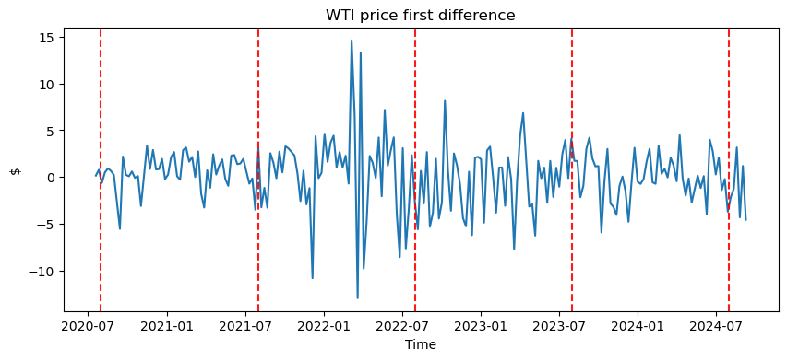

Figure 10 WTI’s price first difference

I then repeated the same modelling process except using an ARIMAX model. This model takes two separate training sets (i.e., endogenous = WTI’s price, exogenous = Texas’ temperature). The two sets must match in length, so I again used everything but the last four months for training. The optimisation section aimed for the optimal arguments such that the BIC is minimised and the result was an ARIMAX(2,1,2). Again, I stuck to the rolling predictions approach, and the result looks like this (Figure 11):

Figure 11. WTI’s price predictions

I then calculated the rolling residual and the same metrics used to evaluate the accuracy of my predictions. The RMSE was $3.220 (i.e., on average, the predicted values deviate from the actual values by $3.220), and the mean absolute error was 0.03418 (i.e., on average, the predictions deviate from the actual values by 3.418%). Here is the rolling residual (Figure 12):

Figure 12. The rolling residual

This concludes the modelling stage. Moving to the forecasting stage, I used all the data for training plus the temperature predictions from above to forecast the next six observations in the same rolling fashion as before. Here are the numbers:

Date Price ($)

2024-09-15 70.876005

2024-09-22 69.530932

2024-09-29 69.679060

2024-10-06 70.731818

2024-10-13 70.735345

2024-10-20 69.941906

Here is how the predictions look on a graph (Figure 13):

Figure 13. WTI’s price predictions

As for predicting the standard deviation of WTI’s price, I first had to calculate the natural log returns. Again, I can not work with WTI’s price time series because it is not stationary, but the natural log returns time series is (Figure 14).

Figure 14. Natural log returns time series

I again took everything I had apart from the last four months of data to train the model and optimise hyperparameters to minimise the BIC. The result was a GARCH(1,1). GARCH is used to predict the variance of a time series, and I took the square root to get the standard deviation of the natural log returns. Here’s the modelled standard deviation (Figure 15):

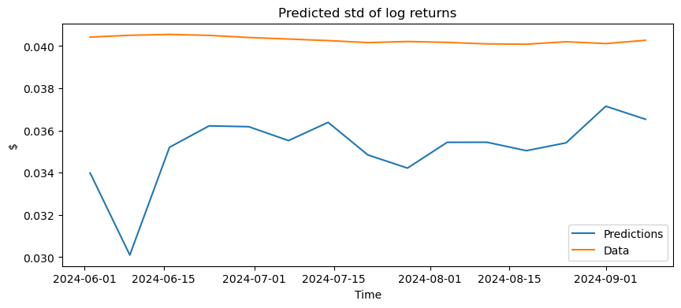

Figure 15. The predicted standard deviation of the natural log returns

I then calculated the rolling residual and the same metrics used to evaluate the accuracy of my predictions. The RMSE was 0.0053, and the mean absolute error was 0.1267. Here is the rolling residual (Figure 16):

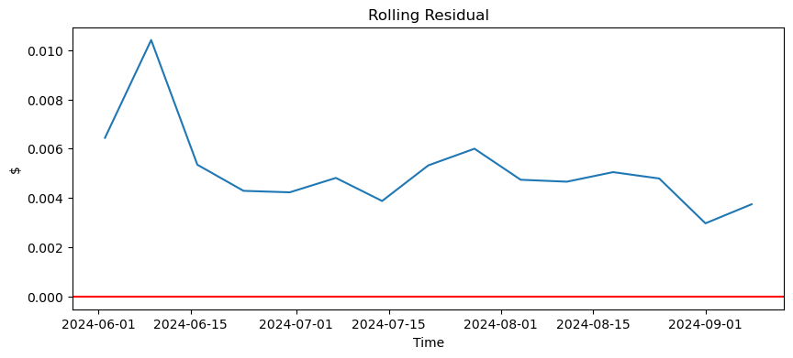

Figure 16. The rolling residual of the modelling outcomes

To predict the standard deviation of log returns, I needed the predicted values of WTI’s price. I had to update the training set with another natural log return observation for each prediction to keep the same rolling predictions approach. However, the observations didn’t come from GARCH because it returns variance. Therefore, I had to calculate the forecasted natural log returns from the forecasted WTI prices and update the training set, which started with all the data I had. I ran the GARCH model, and this was the result (Figure 17):

Figure 17. The predicted standard deviation of log returns

However, this is not WTI’s price standard deviation. According to the Geometric Brownian Motion model, prices are log-normally distributed, and log returns are normally distributed. I then followed these steps where = mean of log returns, = variance of log returns, = the price at the previous time period, = price at period t, r(t) represents the cumulative (possibly stochastic) return over time:

1. If P is log-normally distributed then log(P) is normally distributed which means that:

2)

3) , = moment-generating function of a normal distribution

4) because and since it’s the expectation of an exponential function of a normal variable

Substituting 3) and 4) into 2) we get: , the mean μ cancels out because it affects both terms equally; while μ is part of both exponential terms, it doesn't affect the relative difference between them.

So the final formula is: , which simplifies to

So, having the oil price predictions and the predicted variance of the natural log returns from the GARCH model, I calculated the forecasted variance of WTI’s price and took the square root to get the forecasted standard deviation, and these are the values:

Date Std (WTI’s price)

2024-09-15 1.941149

2024-09-22 1.911082

2024-09-29 1.863511

2024-10-06 1.869676

2024-10-13 1.862525

2024-10-20 1.875293

Here is how they look on a graph (Figure 18):

Figure 18. The predicted WTI price standard deviation

**Further considerations**

With both WTI’s price and WTI’s price standard deviation forecasts, one could create a probabilistic framework for price movement analysis, integrating risk and return. By combining them, one can construct confidence intervals or apply stochastic models like Monte Carlo simulations to map out potential price trajectories. This enables more robust decision-making, whether for risk management (e.g., VaR calculations), option pricing using implied volatility, or devising hedging strategies. Additionally, one can optimise portfolio allocation based on risk-adjusted returns, enhancing capital efficiency in a commodity or broader asset portfolio.

**Disclaimer**

* This content is for informational purposes only and does not constitute financial or trading advice.
* The content should not be considered as a recommendation to trade or invest.
* The authors are not liable for any losses or damages resulting from actions taken based on the information provided.